ACTIVITY #1: POSTING AN AD

Describe the activity
This activity attempts to create an advertisement posting on the website, craigslist.com, in order to help others see the post and contact the seller/advertiser accordingly.

- Posting an ad requires several different steps:
  - First, we have to click the option for Post to Classifieds.
  - Next, we must select the type of posting we would like to post according to the category (for example: posting a job offer in the jobs section or a for sale item under the for sale by owner or dealer section respectively).
  - Finally, we are allowed to fill in the details about the type of ad we would like to post and this tool offers some helpful boxes to complete in order to create the post in a suitable manner.
  - In order to finalize the post, we must submit and verify the submission for the post via email.

- By posting the ad, the user allows the ad to be publicly visible for all other users of the website to view via the search feature. The ad would be displayed under the appropriate search results with the address approximated on a virtual map for users to see how far the location of the advertisement is from their own location.

Describe the user
- Characteristics: the user is typically a local resident of the area about 40 years of age with basic computer usage skills

- System use:
  - Novice: A novice user would be very confused about how to post an ad as they would have to scan through to find the option for creating a post.
  - Expert: An expert, who knows their way around the website, would login to their account with the respective credentials and check the history of his ads as well as manage their current ads such as deleting them or re-posting them to the front of the list.
  - Frequent: A frequent user would be able to guide their way around the website even though there may be some flaws and would typically find it fairly easy to create new posts according to the appropriate section for creating a proper ad posting.
  - Casual/infrequent: A casual or infrequent user may possibly find it challenging to understand the concept of the website and in return turn to another similar website which would let them create ad postings that are more user friendly compared to Craigslist.

Empathy map
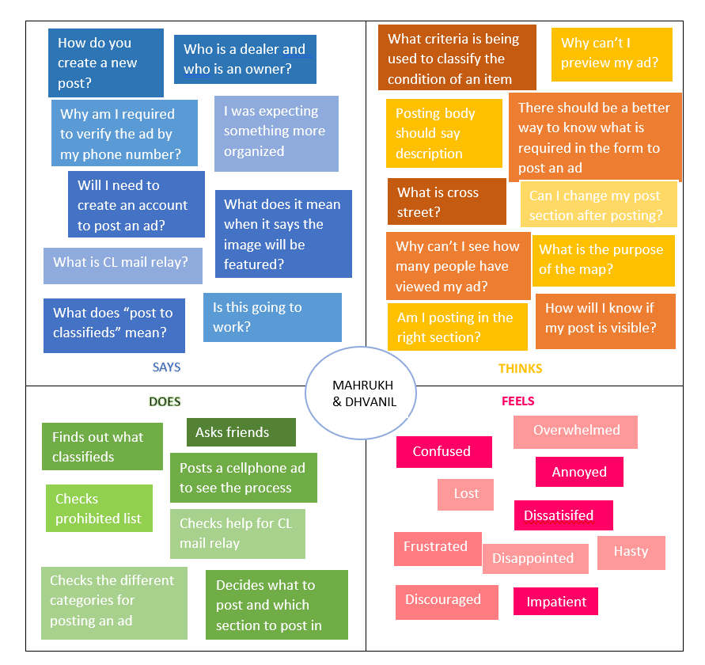

Requirements

Requirement #: 1 Requirement Type: Functional

Description: When posting an ad, the form should allow the user to select more than one category for their post.

Rationale: Since an advertisement could possibly fit into more than one category, the posting an ad form should allow the user to select more than one category for the post.

Originator: Dhvanil

Customer satisfaction: 3 Customer dissatisfaction: 2

Requirement #: 2 Requirement Type: Non-Functional

Description: When posting an ad, the form should have a list for locations in the specific location section.

Rationale: This could help users specify the vicinity rather than openly specifying their location due to security purposes.

Originator: Dhvanil

Customer satisfaction: 4 Customer dissatisfaction: 1

Requirement #: 3 Requirement Type: Functional

Description: When posting an ad, the language of posting should always remain English and later allow for various language changes when searching.

Rationale: Users creating posts can sufficiently create posts in English and it can provide other users to view the ad in English or in any other language of their preference when searching.

Originator: Dhvanil

Customer satisfaction: 4 Customer dissatisfaction: 2

Requirement #: 4 Requirement Type: Functional

Description: When posting an ad, the form should allow for online payment options the user can allow for the customers.

Rationale: If a user wants to advertise an online service, they should have the option to select an online payment option such as Paypal or Skrill in order to easily take payments.

Originator: Dhvanil

Customer satisfaction: 4 Customer dissatisfaction: 1

Requirement #: 5 Requirement Type: Functional

Description: When posting an ad, the form should clearly identify what is required and what is optional.

Rationale: Need to know which form inputs are required so user can choose to only give information that is necessary.

Originator: Mahrukh

Customer satisfaction: 3 Customer dissatisfaction: 2

Requirement 5 - Current system:
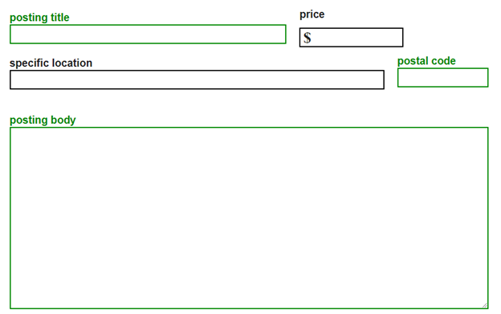

Requirement #: 6 Requirement Type: Functional

Description: When a user is viewing an ad, the ad should display how many visitors have come across the ad.

Rationale: This will allow users to gauge how popular their own ad is and will allow other users to determine the popularity of ads.

Originator: Mahrukh

Customer satisfaction: 5 Customer dissatisfaction: 2

Requirement 6 - Current system:
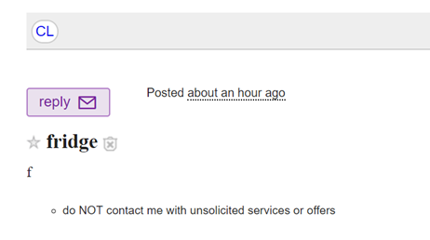

Requirement #: 7 Requirement Type: Functional

Description: A well-defined scale should be used for conditions of an item.

Rationale: This will allow users to specify the condition of their item in a more user friendly and logical style since the current categories (new, like new, excellent, good, fair, and salvage) are vague and ill-defined.

Originator: Mahrukh

Customer satisfaction: 2 Customer dissatisfaction: 2

Requirement 7 - Current System:
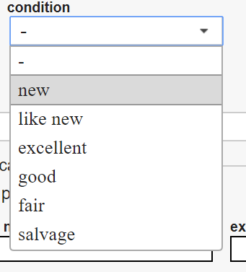

Requirement #: 8 Requirement Type: Functional

Description: Users should be able to preview their ad in the listing pages.

Rationale: This will allow users to ensure that their ad is displayed as specified, posted in the correct category and accessible by the search engine.

Originator: Mahrukh

Customer satisfaction: 5 Customer dissatisfaction: 4

Requirement #: 9 Requirement Type: Functional

Description: There should be a large header and a clear explanation of the purpose that craigslist.com serves on the home page.

Rationale: This will allow users to fully understand the objective of craigslist.com as currently the aim seems unclear and the main page looks disorganized.

Originator: Mahrukh
Customer satisfaction: 5 Customer dissatisfaction: 5

ACTIVITY #2: SEARCHING FOR AN ITEM

Describe the activity
This activity searches for the data in the database using the help of keywords we have put in the textbox. We can search with at least one keyword upto n number of keywords.

Case 1: While we put keywords it fetches the data in real-time and shows if it is present in the database or not.

For example:

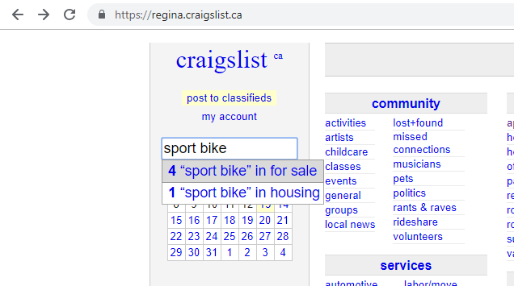

Case 2: We can put n number of words in the search textbox and it will not fetch any result.

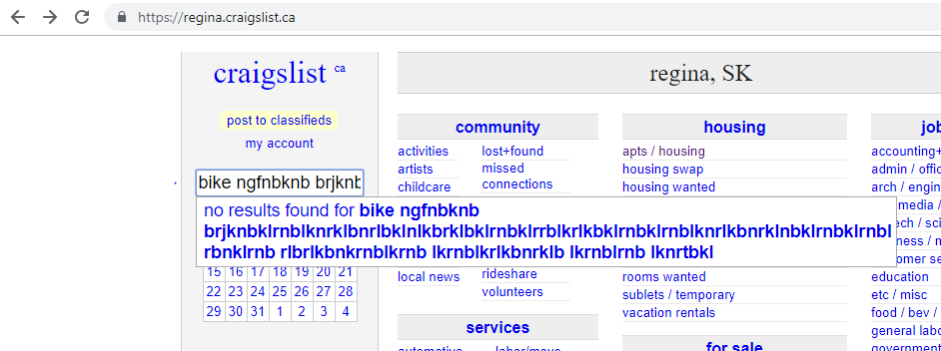

Describe the user
- Characteristics: The user is a Canadian citizen and 38 years of age with basic knowledge of computers.
- System use:
  - Novice: the new user will find it difficult to find the search box and how to search.
  - Expert: An expert user may also find it is difficult to search and will be irritated with such a UI design.
  - Frequent: A more frequent user may be able to find the search box but the UI experience will not be pleasant and would lead to displeasure.
  - Casual/infrequent: An Infrequent user will close this website and navigate to a different website as they will understand the purpose of this website.

Empathy map
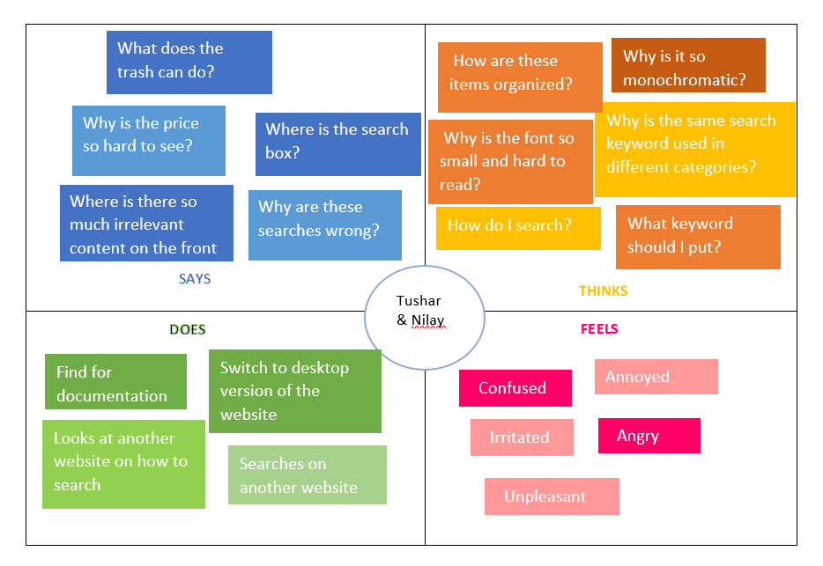

Requirements

Requirement #: 1 Requirement Type: User Interface

Description: When users are viewing the website the search box should be focused.

Rationale: The search box is important so it should be focused and at the center on the top.

Originator: Tushar

Customer satisfaction: 1 Customer dissatisfaction: 4

Requirement #: 2 Requirement Type: User Interface

Description: The search box should take limited keywords.

Rationale: Currently, the search box accepts n number of keywords which is inefficient.

Originator: Tushar

Customer satisfaction: 0 Customer dissatisfaction: 5

Requirement #: 3 Requirement Type: Security

Description: There should be server side validation for the number of keywords .

Rationale: The server side should have validation when accepting number of keywords otherwise the site may crash if someone tries to hack the website.

Originator: Tushar

Customer satisfaction: 1 Customer dissatisfaction: 4

Requirement #: 4 Requirement Type: User Interface

Description: The search box width should be bigger.

Rationale: The width of the search box should be larger so it is easier for the user to see what he or she is typing.

Originator: Nilay

Customer satisfaction: 1 Customer dissatisfaction: 4

Requirement #: 5 Requirement Type: Functional

Description: The system should reduce irrelevant and incorrect results after search.

Rationale: There should be a filter at server side which removes illegal and irrelevant results from database.

Originator: Nilay

Customer satisfaction: 3 Customer dissatisfaction: 2

